1. The Objective

To build a Desk Monitoring system which reports whether or not somebody is sitting at a desk and writes this information to a Database far far far away.

The Problem:

Our Solution: To build a cost effective Desk monitoring system which uses ultrasonic waves to indicate a person within the field range and reports to a database.

2. Core Components and its Pinout

Arduino Nano:

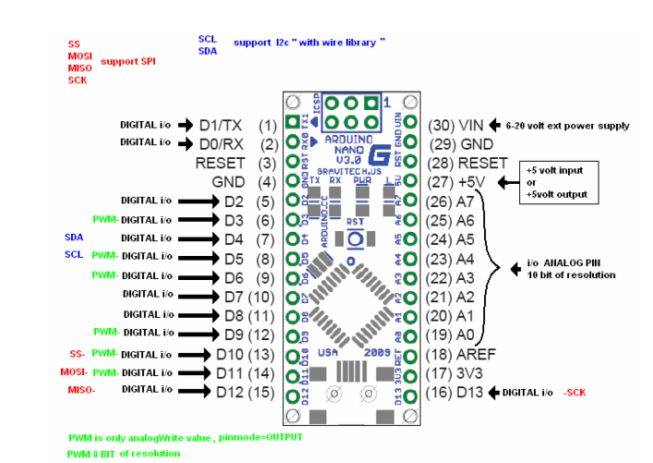

Ultrasonic Sensor:

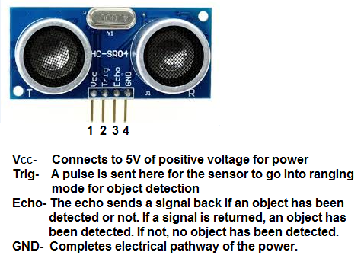

**VCC -> 5v -- Red Wire**

**TRIG -> D4 -- Yellow**

**Echo -> D3 -- Green**

**GND -> GND -- Black**

nRF24L01:

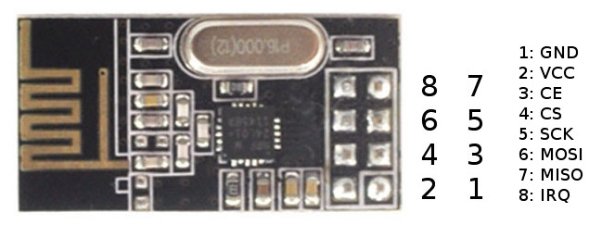

1 – GND -> GND -- Brown Wire

2 – VCC -> 3V3 -- Red

3 - CE -> D8 -- Yellow

4 - CS -> D7 -- Orange

5 – SCK -> D11 -- Blue

6 – MOSI -> D13 -- Green

7 – MISO -> D12 -- Violet

## 3. The Arduino Sketch

// --------------------------------------------------------------------------------------------------------------

// Arduino Sketch for Measuring Distance and Transmitting Data using Ultrasonic ranger and nRF24L01 Module Resp. // Sender

// --------------------------------------------------------------------------------------------------------------

#include <NewPing.h> // Newping Library for Ultrasonic Sensor

#include <SPI.h> // Serial Peripheral Interface Library for Short Distance Communication

#include <nRF24L01.h> // nRF24L01 Library

#include <RF24.h> // RF24 Library

#define TRIGGER_PIN 4 // Arduino pin tied to trigger pin on the ultrasonic sensor.

#define ECHO_PIN 3 // Arduino pin tied to echo pin on the ultrasonic sensor.

#define MAX_DISTANCE 200 // Maximum distance we want to ping for (in centimeters). Maximum sensor distance is rated at 400-500cm.

RF24 radio(7, 8); // Radio Pins D7, D8

const byte rxAddr[6] = "00001"; // Receiving Arduino with nRF24L01 Address

NewPing sonar(TRIGGER_PIN, ECHO_PIN, MAX_DISTANCE); // NewPing setup of pins and maximum distance.

void setup() {

Serial.begin(115200); // Open serial monitor at 115200 baud to see ping results.

radio.begin(); // Start Radio on Sender Device

radio.setRetries(15, 15); // Retries for Transmission

radio.openWritingPipe(rxAddr); // Open a pipe for writing with receiving address

radio.stopListening(); // Stop the Radio Listening

}

void loop () {

delay (50); // Wait 50ms between pings (about 20 pings/sec). 29ms should be the shortest delay between pings.

unsigned int uS = sonar.ping(); // Send ping, get ping time in microseconds (uS).

unsigned int dist = uS / US_ROUNDTRIP_CM; // Convert ping time to distance in cm and print result (0 = outside set distance range)

const char yes[] = "Y"; // Constant character declaration

const char no[] = "N"; // Constant character declaration

if (dist > 0 && dist < 60) { // If the measured distance from ultrasonic sensor is greater than zero and less than 60cms Transmit character Y to the receiving arduino

radio.write("US02: Y",yes);

}

else {

radio.write("US02: N",no); // Else Transmit character N to the Receiving Arduino

}

}

## Arduino Sketch for the receiver